Press release

**VELUX and JET to build a new division: VELUX Commercial**

**VELUX acquisition of JET-Group was approved on 19th November last year. Since then, the two companies have taken the first steps to build a new division under the VELUX brand. Now they are launching a new logo and visual identity.**

With the acquisition of JET-Group, the VELUX Group became one of the leading players in the commercial market in Europe. Combined with its recent acquisitions of Wasco and Vitral, and the ongoing development of VELUX Modular Skylights, the VELUX Group will now build a new commercial division and grow its business to the benefit of customers in the commercial market. On a short-term basis, JET-Group and VELUX Modular Skylights will continue business as usual.

The VELUX Group has built its business on bringing daylight and fresh air to people’s homes through more than 75 years, and has achieved a clear market leader position in the residential market for roof windows. The VELUX Group’s first step into the commercial (non-residential) market was in 2012, when it launched VELUX Modular Skylights with a strong ambition to bring daylight and fresh air into commercial buildings too.

The commercial market consists of two main segments:

* An architectural glazing segment, focussed on design, with architects playing a significant role in selecting glass or acrylic glazing solutions
* An industrial flat roof segment, which consists almost entirely of acrylic solutions, such as domes, continuous roof lights (CRLs) and smoke- and heat ventilation exhaust solutions.

The two segments vary significantly in terms of customer groups and sales processes. VELUX has a strong presence in the architectural glazing segment with VELUX Modular Skylights, while JET has a leading position in the industrial flat roof segment, and VELUX Commercial will cover both segments.

“We are looking forward to work together on building the new commercial division under the VELUX brand. We see growth potential and possibilities to strengthen our business to the benefit of customers and employees,” says Ralf Dahmer, CEO of JET-Group. Ralf Dahmer will head the operating area for the industrial flat roof segment in VELUX Commercial.

“Our strategy is to grow our business by bringing daylight to people in commercial buildings, and by joining forces with JET, we gain scale and we enter a whole new segment. The products and the sales process in the commercial market are quite different from the residential market, and to meet the specific needs of the commercial market, we are now building a new division; VELUX Commercial”, says Henrik Øvlisen, VP of VELUX Modular Skylights, who will head the operating area for architectural glazing in VELUX Commercial.

To visibly differentiate the product offer in the commercial market from the well-known VELUX roof window and to establish a visual framework for the creation of the new commercial division, the VELUX Group is now launching a VELUX commercial logo and visual identity.

The VELUX Commercial logo and the visual identity is shown for the first time in public at the BAU on the VELUX and JET stands, and will be rolled out during the coming months in most of Europe as a first visual signal to the market, that VELUX is building something new together with JET.

**About the VELUX Commercial logo and visual identity**

The VELUX Commercial logo and visual identity is developed within the existing colour palette of VELUX corporate identity.

The new logo emphasises that this is a division under the VELUX brand by using the VELUX logo as the foundation. The black colour with Commercial highlights the focus on the commercial market.

The visual identity colour palette prioritises the anthracite grey as a primary colour and by adding new shades of blue referring to the skylight solutions, the new visual identity expresses the contrast between light and shadow exactly as the effect of the skylight solutions do. By using the VELUX typography, the close link to the VELUX Brand is further enhanced.

**About the JET-Group**

The JET-Group was founded in 1970. Today they have nearly 800 employees, is headquarted in Hüllhorst Germany and has own sales offices in 7 countries: Germany, Poland, Denmark, Norway, The Netherlands, The United Kingdom, and Switzerland, and 6 production sites in 4 countries: Germany, Denmark, Great Britain, and The Netherlands

**About VELUX Commercial**

VELUX Commercial covers Wasco, Vitral, JET and VELUX Modular Skylights organisations and has in total close to 1,200 people working in sales, production and administration in 13 countries providing a broad product offering ranging from industrial flat roof products and smoke- and heat ventilation exhaust solutions to modular, prefabricated skylight solutions.

**About the VELUX Group**

For more than 75 years, the VELUX Group has created better living environments for people around the world; making the most of daylight and fresh air through the roof. Our product programme includes roof windows and modular skylights, decorative blinds, sun screening products and roller shutters, as well as installation and smart home solutions. These products help to ensure a healthy and sustainable indoor climate, for work and learning, for play and pleasure. We work globally – with sales and manufacturing operations in more than 40 countries and around 11,000 employees worldwide. The VELUX Group is owned by VKR Holding A/S, a limited company wholly owned by non-profit, charitable foundations (THE VELUX FOUNDATIONS) and family. In 2017, VKR Holding had total revenue of EUR 2.5 billion, and THE VELUX FOUNDATIONS donated EUR 170 million in charitable grants. For more, information, visit [www.velux.com](http://www.velux.com).

**Captions for images**

Image: core.jpg:

The new logo emphasises that this is a division under the VELUX brand by using the same shape and the same red colour as the VELUX logo.

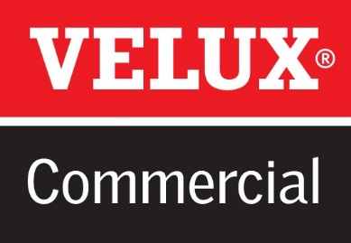

Image: square building icons_rgb_antracit.jpg

The VELUX Groups’ strategy is to expand its business from the residential market to the commercial market, and not only bring daylight and fresh air into peoples’ homes - but **also** to commercial buildings. The commercial market is all the other types of buildings, where people spend their time during the day: offices, schools, healthcare facilities, shopping malls and retail stores as well as large public buildings and industrial buildings.

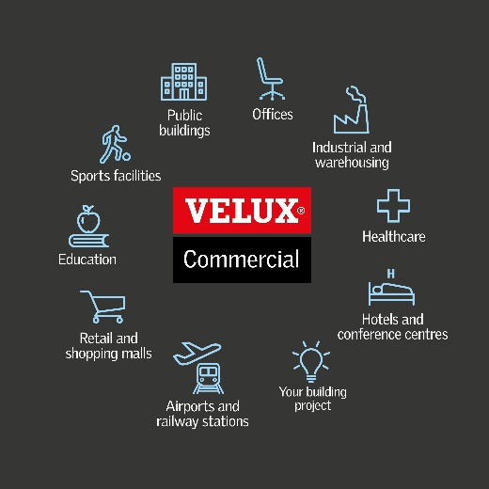

**Contact**:  
Jens Bekke, Director Global Media Relations in VELUX Group, +45 2155 0789